When the Hotel Whittier burned, the town was left without a first-quality restaurant for many years. This situation changed in 1931, when Albert Lamie, who had operated a small restaurant in the Village, purchased the E. Warren Lane homestead on the north corner of Lafayette and Exeter roads. He turned the old house around to face Lafayette Road and raised it one story. His new Lamie's, with wood paneling and a huge fireplace, soon became one of the finest and best-known restaurants in New England. For travelers between Boston and Portland, Maine, Lamie's became the place to stop for lunch and dinner, and at times it was open 24 hours a day. Lamie soon had to expand his dining room, so he purchased the former J. A. Lane & Company store, then the Hampton Union office, to use as a function room. He sold the business in 1940 to brothers Frank and Alfred Tower. After Frank died, Alfred operated the restaurant until 1954, when he sold it to another set of brothers, the Dunfeys, who were to use the property as their base for developing one of New England's largest and most successful innkeeping businesses, combining hotels with real estate and insurance.
Catherine and Leroy Dunfey, who a ran a small variety store in Lowell, were assisted by their family of eight boys and four girls, most of whom began working in the store during their nonschool hours at ages eight or nine. In 1945, Leroy bought a small cottage on Nudd Avenue at Hampton Beach. While on a morning walk one day in 1946, he met Fred Haywood, who owned a fried-clam stand situated between the Ashworth and DeLancey hotels. Haywood wanted to sell his business, and Dunfey bought it for $25,000 for his children to run. Taking over from Haywood after the 1946 Fourth of July weekend, older brothers John and William, who had just finished World War II service, had a successful season, selling 10 to 12 gallons of clams daily and making a profit that equaled the purchase price. They had no idea the business could be so lucrative, Bill Dunfey recalled 40 years later. On hot nights and on Labor Day weekend, they remained open 24 hours, selling clams and hot dogs until 3 A.M., then switching to doughnuts, serving the many people who in those days were allowed to sleep on the beach. Younger brothers Robert, Walter, and Gerry also joined the business.
By 1949, the brothers also had purchased a small restaurant, a student supply store, and a laundromat in Durham, where they were students at the University of New Hampshire. At first the brothers viewed their Durham and Hampton Beach businesses only as ways to finance their college educations, but a major change occurred after the 1950 Beach fire. Paul Hobbs accepted their high bid for a lease on his new building at the corner of C Street. This prime Beach location was immediately successful and the Dunfeys sold their other Beach businesses, two of which were bought by brothers Robert and Russell Preston.
To keep busy in the off-season, Bill and Bob opened a real estate and insurance office above Harry McDormand's store in the Village. A chance meeting with Al Tower in 1954 resulted in the Dunfeys' purchase of Lamie'sTavern. To Bill Dunfey, Lamie's seemed "as large as the Amoskeag Mills" in Manchester.
"The purchase of Lamie's redefined conceptually what we were going to do," Bill explained. "Prior to that purchase, we were shortorder cooks, selling clams, hot dogs, candy, and pizza at the beach, and selling hamburgers, pizza, and student supplies in Durham. Lamie's had a good reputation and we had to live up to it. We adopted the theme, set by the restaurant, of 'good old New England hospitality."' "Cracker Barrel" lounges became standard in later Dunfey properties. First the Dunfeys surprised conservative Hampton when they secured for Lamie's the first local liquor license since Prohibition. Since liquor at first could only be served to nonresidents, Bill prepared a card for patrons to sign, declaring they were nonresidents and over 21 years of age. "Middle-aged tourists got quite a kick out of the card," Bill remembered. When they added a 32-room motel, decorated with an Isles of Shoals theme, to Lamie's in 1958, the brothers realized that renting rooms was more profitable than selling liquor or food.
The following year, they bought the bankrupt Carpenter Hotel in Manchester, and in 1961 they acquired the bankrupt Eastland Hotel in Portland. Both large properties were turned into profitable businesses. The family corporation evolved with John as president and treasurer, Walter running the Carpenter, Robert at the Eastland, Gerry managing another hotel in Burlington, Vermont, and Bill operating the real estate and insurance offices.
They continued to buy smaller hotels and inns throughout New England, but the business took another major leap in 1968, when they purchased the once-luxurious, but near-bankrupt, Parker House in Boston. This move resulted in another successful property. Bill Dunfey said the working plan for the family in the innkeeping business was to purchase existing hotels and to renovate the properties rather than to build all-new facilities. Since this concept required large amounts of capital, the Dunfeys sought a host corporation that would purchase them, retain the family as managers, and supply the needed expansion funds. In 1971, the business of 18 hotels and motor inns was sold to Aetna Life Insurance Company of Hartford, Connecticut. At the time, the Dunfeys resisted Aetna's attempts to move their headquarters out of Hampton. Several of the brothers, as well as a number of longtime employees, lived in town or nearby, and the family wanted to remain here. Six months later, as Aetna was about to foreclose on a mortgage for the five large Royal Coach hotels, the Dunfeys convinced the company to let them take over the hotels. This gave the Hampton-based corporation properties in five major United States cities and turned the business into a national innkeeping chain. The jewel of the chain was Berkshire Place in New York City, a major residential hotel purchased in 1973.
In 1976, the family orchestrated the sale of the business from Aetna to Aer Lingus, the Irish national airline, and the Dunfey chain became international, with hotels in Paris, London, and Ireland. When Catherine Dunfey, the family matriarch and honorary chair of the board, died in 1982 at age 87, the Dunfey chain owned or operated 26 hotels with some 10,480 rooms. Family members ceased active management of the company in 1985. Two years earlier, with the purchase of the Omni Hotel chain, the Dunfey name began to be phased out. In 1988, Omni Hotels was sold for $135 million to Wharf Holding Company of Hong Kong, led by Y. K. Pao, the largest shipowner in the world. This business continues to operate in Hampton with several employees who originally worked for the Dunfey family at Hampton Beach in the late 1940s. According to Bill Dunfey, Aer Lingus, which purchased the Dunfey hotel business for a $250,000 investment, had previously sold the New England hotels to the Flatley Company for $56 million, and Aer Lingus retained Berkshire Place, now valued at $100 million. From a $25,000 Hampton Beach clam stand, the value of the Dunfey properties in 1988 had reached over $250 million. Even David Nudd, the wily owner of several Hampton Beach hotels in the nineteenth century, would be impressed.
The Dunfey brothers have now formed the Dunfey Capital Group, located in Portsmouth. This venture-capital firm, with social concern criteria, concentrates on projects in northern New England. The Dunfeys have long been active in Democratic party politics, especially Bill, who ran the New Hampshire presidential campaign of John F. Kennedy and was a national party committee member. He was also appointed a citizen delegate to the United Nations. In 1976, 19-year-old Stephen Dunfey, son of John, was elected to the State Legislature from Hampton and was the youngest member of the House in that session.
In 1959, the First National supermarket opened adjacent to Lamie's. The largest new building in the community since the construction of the Casino at the turn of the century, the First National had been operated for the previous 24 years from a store at 438 Lafayette Road [now the Annex of Caffe Fresco in 2005], in a building constructed by Thomas Cogger in the 1920s. In recent years it has been occupied by the Bib and Crib, a shoe store, and the Vanity Case. The First National closed in 1969, when its lease with the Dunfeys ended and the building was converted to Dunfey offices. In 1967, the Great Atlantic & Pacific Tea Company (A & P) opened a new store in the Edgewood Shopping Center, south of the Village. The A & P had originally been in the Merrill Block on High Street and in the mid-1940s moved into a new building at 447 Lafayette Road, currently McDormand's. The A & P lasted until 1980, when, as the town's only large supermarket, it closed, to be replaced by S & R Supermarket. It too closed in the mid-1980s, and Hampton was without a major market for the first time in about 100 years -- until 1987, when Super Shop and Save [name changed in 2002 to "Hanaford"] opened on Lafayette Road. This super store, supposediy a new concept in marketing, combines a diverse offering of groceries, greeting cards, small appliances, and video rentals with a pharmacy, bakery, florist, and fish market. While this diversity seems novel today, it is a concept that closely resembles the old general stores of Lane and Cole. In other 1967 store changes, the Exeter & Hampton Electric Company moved adjacent to the A & P, and their old store in Marelli Square became the House of Joy, a religious bookstore operated by the Reverend and Mrs. Howard Danner.

Catherine and Leroy Dunfey Award:
Changing Our World One Person At A Time

About the Award

Catherine Manning and Leroy Dunfey met at the Lowell textile mills where they, like so many of their generation, started working at the age of twelve. Their marriage, a decade later, produced what Catherine liked to describe as the 'birth of a nation'. twelve children, thirty-five grandchildren and numerous great-grandchildren.
In her memoirs, Catherine writes: 'In the store on Broadway, Dad-who served as an unpaid Welfare Commissioner - acquainted the children with how to serve others ... it was the ideal spot located in the Acre, a neighborhood f the Irish, Greek, French, Polish and Italian-a place to learn all their customs. What a start for children growing up in a world where other countries seemed far away. Their curiosity about what was beyond the other side of the counter led our sons and daughters in later years to look at what was on the other side of the world.
After Roy's sudden death in 1952, Catherine became a vital part of her family's emerging business, demonstrating an ability not only to endure, but change and rise to the call of leadership. She assumed her position as chairman of the board of the Dunfey Family Hotels later Omni Hotels, in the same quiet yet strong manner that had characterized her through the years.
Catherine and Leroy Dunfey were distinguished-not by birth, education or world achievement. What distinguished them was their celebration of the human spirit-its resiliency, its courage and generosity. It was their gift of valuing the importance of each person that moved the Dunfey family and New England Circle / Global Citizens Circle to establish the annual Catherine and Leroy Dunfey Award.
In honoring 'Mo' Mowlam with this award, Global Citizens Circle recognizes the "personal courage" of the recipient and her capacity to work closely with women and men of different ideologies.' Global Citizens Circle, founded as New England Circle, is privileged to present the 1999 Catherine and Leroy Dunfey Award to Dr. Marjorie 'Mo' Mowlam.

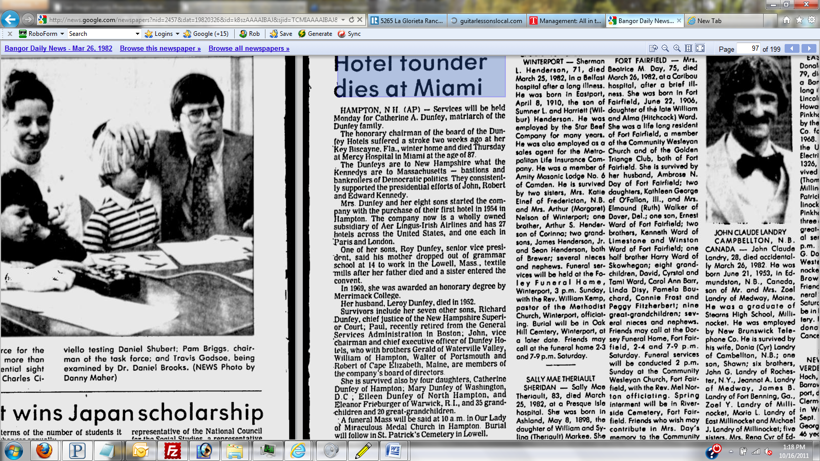
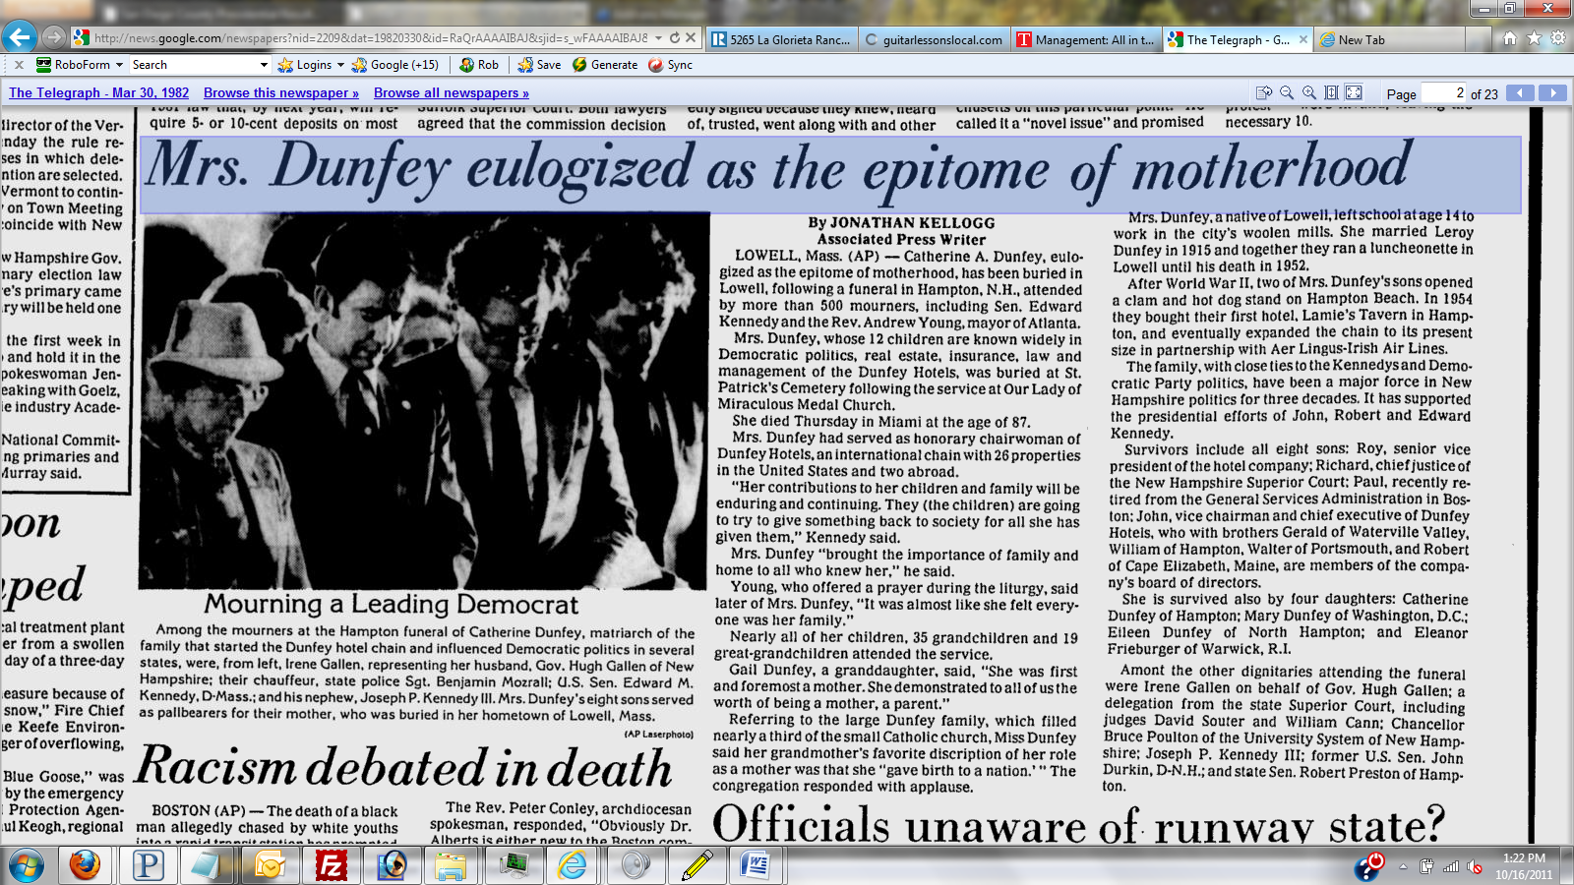

Unanimous Decisions
After Leroy Dunfey opened a luncheonette in Lowell, Massachusetts, in 1918, he grew his own help-eight sons and four daughters. "Dad didn't pay us, but we always ate well," remembers John P. Dunfey, who waited on tables and washed dishes when he was seven. The luncheonette was sold long ago, and Leroy is dead. But John, now 54, his mother, Catherine, 83, and five of his brothers, Roy, 62, William, 52, Robert, 51, Walter, 46, and Gerald, 43, are still business partners. Today, they own twenty-five hotels.
[PICTURE]
John and Walter Dunfey of Dunfey Family Hotels
Sales of the Dunfey Family Hotels, based in Hampton, New Hampshire, totaled $77 million last year. The company owns the 125-year-old Parker House in Boston, one of the oldest in the U.S., and the Ambassador East in Chicago. Recently the Dunfeys paid $9 million for Manhattan's Berkshire Hotel, a favorite of such luminaries as Ethel Merman and the late Edward R. Murrow.
With a $5-million face-lift and a new name, the Berkshire Place, the Dunfeys hope to restore the hotel to its former grandeur. Crystal chandeliers and Oriental screens will grace the new lobby. A fulltime concierge will pamper Berkshire patrons, and there will be fresh flowers and Godiva chocolates in every room. "When we're done, we'll have a gracious lady on Madison Avenue," says John, who is president of the family firm.
Two years ago the Dunfey Family Hotels became a subsidiary of Aer Lingus, the Irish airline. But the Dunfeys still pride themselves on their homespun management style. Twice a month they hold "brothers' meetings" in a second-floor room at Lamie's Tavern in Hampton. Lamie's was their first major joint investment, in 1954. At their meetings they have heart-to-heart talks about both business and family. All decisions are unanimous.

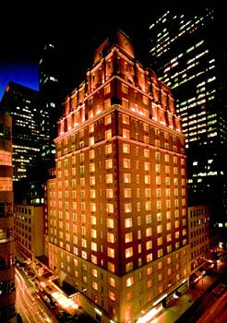 OMNI BERKSHIRE PLACE -Bought for $9 million.
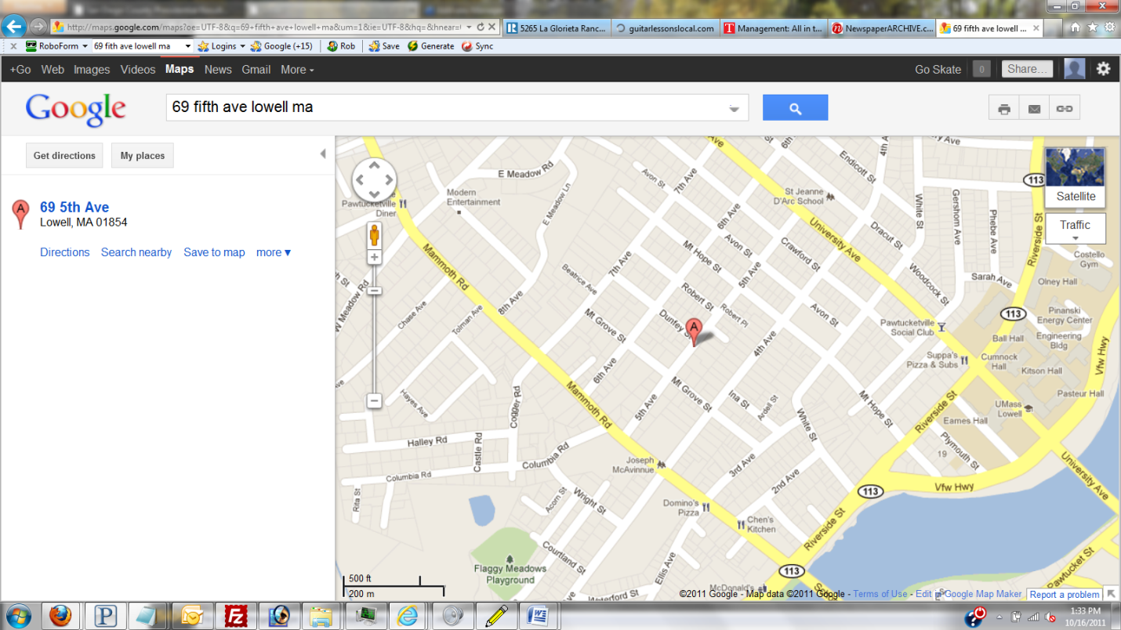
Robert and Dunfey St’s

The Family Table
Bringing people together comes naturally for Eleanor, who got her first lessons in hospitality and service from her parents, Irish Catholic immigrants who left school to work in the textile mills in Lowell, Mass. By the time Eleanor was born in 1938, the youngest of 12 children, her father owned a variety store where all the children helped out. A gregarious man who knew everyone in their immigrant neighborhood, he served as the city’s volunteer welfare commissioner.
Eleanor remembers walking downtown with him to meetings at the Knights of Columbus, an international service organization, and standing on street corners while he chatted with the people they met. If anyone needed a hot meal and a kind word, he invited them home. The dinner table was the center of family life; people of all races, nationalities and social backgrounds were welcome. Her mother fed everyone and listened to their troubles with a quiet sympathy that made each of her children and guests feel special.
“We always had room for someone else at the table,” Eleanor said.
With World War II ending and three of the older boys heading home from the service, Eleanor’s father leased a tiny clam stand on the beach in Hampton, N.H., to get them started in business. Eleanor began work there at age 8, standing on a Coke crate so she could see over the counter.
Her father died when she was 12 and the family moved to Hampton, where they had opened a second clam stand and were building a full-size restaurant. Dunfey’s on C Street opened on Hampton Beach in 1951 with 75 employees, 17-year-old Jerry as the manager, and 13-year-old Eleanor – who was tall for her age and looked older by wearing lipstick – in charge of training the waitresses.

Lamie's Tavern New Luxury Motor Inn

Dunfey Family Enterprises

Boston Globe, June 27, 1979
HAMPTON, N.H. -- A continuance of the tremendous growth of the business enterprises of the Dunfey family of Hampton and Durham, New Hampshire, was further illustrated this past week with the opening of a new motor inn and restaurant, adjacent to the historic Lamie's Tavern on Rte. 1 In Hampton Center.
The 32 unit motor inn is a two-story, garrison-colonial style structure and features a new dining room. The main entrance faces Lafayette Road, at the north end of the Tavern. A spacious lobby provides easy access to the five dining rooms, coffee shop and all other facilities of the present building.
The units in this new motor inn are fireproof, soundproof, with wall to wall carpeting, the decorative motif being early American. All units are equipped with television, telephones and individual controls governing heat and air-conditioning. In addition to these motel conveniences, guests are afforded full hotel services.
The new dining room, "The Shoals," is air-conditioned with a capacity of 100 guests, and offers a menu specializing in sea foods. The historic Isles of Shoals, where the first fishing stations in America were located furnishes the inspiration for the unusual decorative motif.
This expression of confidence in the healthy economy of New Hampshire and especially the seacoast area by the Dunfey family comes as no surprise to those who are acquainted with the diversified enterprises of this unusual family.
Thirteen years ago the family opened a clam stand on a small corner location at Hampton Beach. Today they own one restaurant, an amusement center and a food shop at the beach; a department store and a business block in Durham; Lamie's Tavern with its beautiful new motor lodge, a thriving insurance business in Hampton and a realty company with offices in Hampton and Hampton Beach. In 1958 they helped organize the Hampton National Bank. Several months ago the Dunfey family purchased the 214-room Carpenter Hotel in Manchester, one of the largest in the state.
The Dunfey business family are the widow and sons of Leroy W. Dunfey who commenced his business 41 years ago when he opened a variety store in Lowell, Mass. The original family consisted of eight sons and four daughters. All four Dunfey girls have become Catholic nuns.
Sister Ann Francesca (Mary) is at the Star of the Sea Convent in Hawaii. Sister Julie Francesca (Eileen) is at St. Michael's in Exeter; Sister Francesca (Kay) is on the teaching staff at Emmanuel College in Boston. The youngest daughter, Sister Catherine LeRoy (Eleanor) is at the Notre Dame Convent in Waltham.
The varied Granite State businesses are conducted by Mrs. Catherine Dunfey and five of her sons, John P., William L., Robert J., Walter J., and Gerald F., with legal counsel from a sixth brother, Richard P. of Exeter. The two other brothers, Paul and Roy, hold responsible positions in other parts of the United States.
General manager of all the Dunfey interests is John. He is 35, an ex-Air Force pilot, married (as are all the boys) and has four children. He lives in Hampton as do all the New Hampshire Dunfey's except Walter and Richard.
William, manager of the real estate and insurance activities is keenly interested in the political and public affairs of the state and at age 33 is a member of the N.H. State Library Commission.
Robert, 33, is responsible for the operation of Lamie's Tavern and the operation of "Playland" at Hampton Beach. He is a vice president and director of the Portsmouth Board of Realtors and treasurer of the state Realtors Assn.
[missing words, referring to Walter] Durham Dunfey enterprises during the school year, then transfers to the Hampton area for the vacation season. He is president of the Durham Men's Club, vice president of the Granite State Restaurant Assn. ia member of the Durham Budget Committee and the Dover Lions Club.
The youngest brother, Gerald, 23, graduated from the University of New Hampshire and is in charge of restaurant operations at Hampton Beach.
During the Summer months the various Dunfey operations employ 225 persons with a drop to about 125 in the other seasons.
* * *
According to Mrs. Catherine Dunfey the key to the success of the family undertakings is the priceless possession of family unity. She revealed that the family always prayed, worked and enjoyed social pleasures together and that is still in practice today.
Perhaps there is another secret to the Dunfey success story and it is in the area of employee relationships. By doing a great many things that add up to being nice people to work for, the Dunfey enterprises have assembled a competent and loyal family of employees.
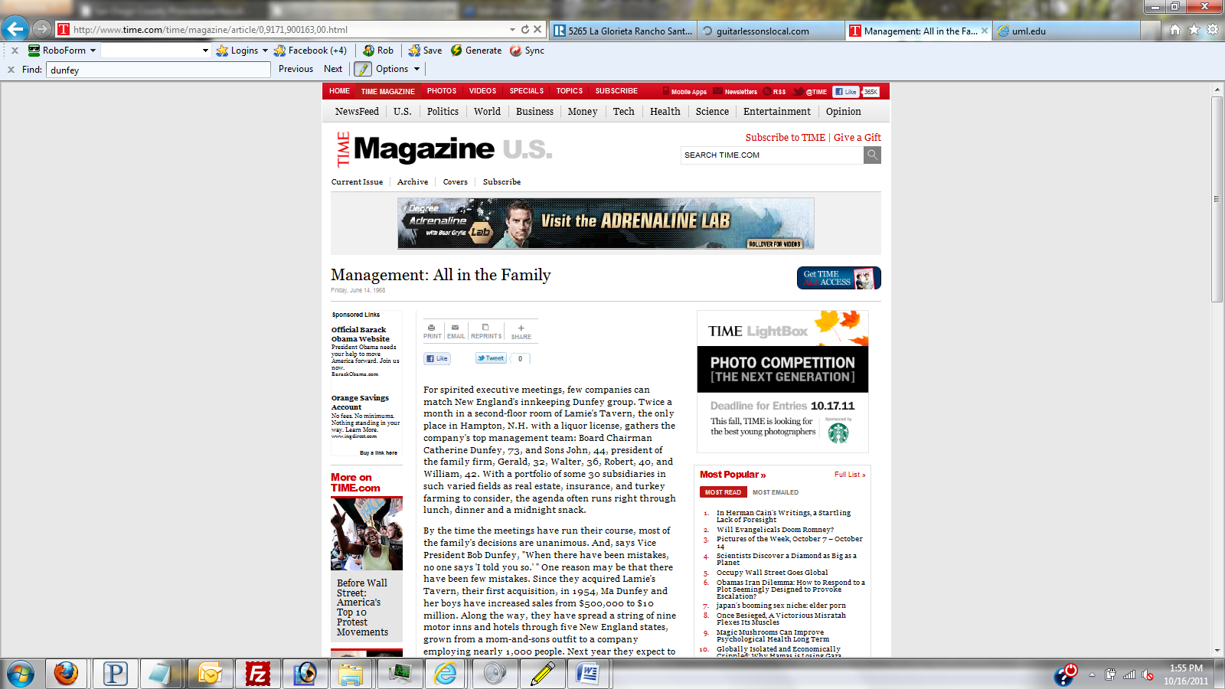

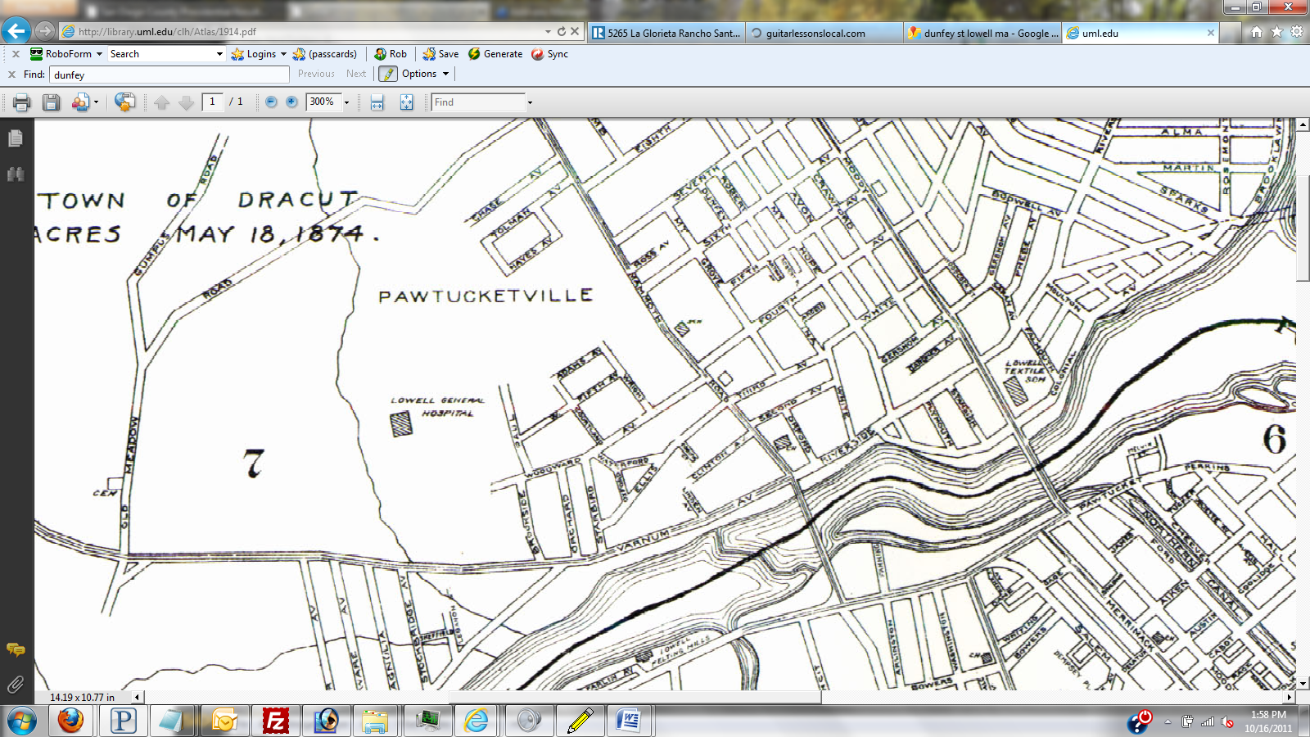Map from 1914

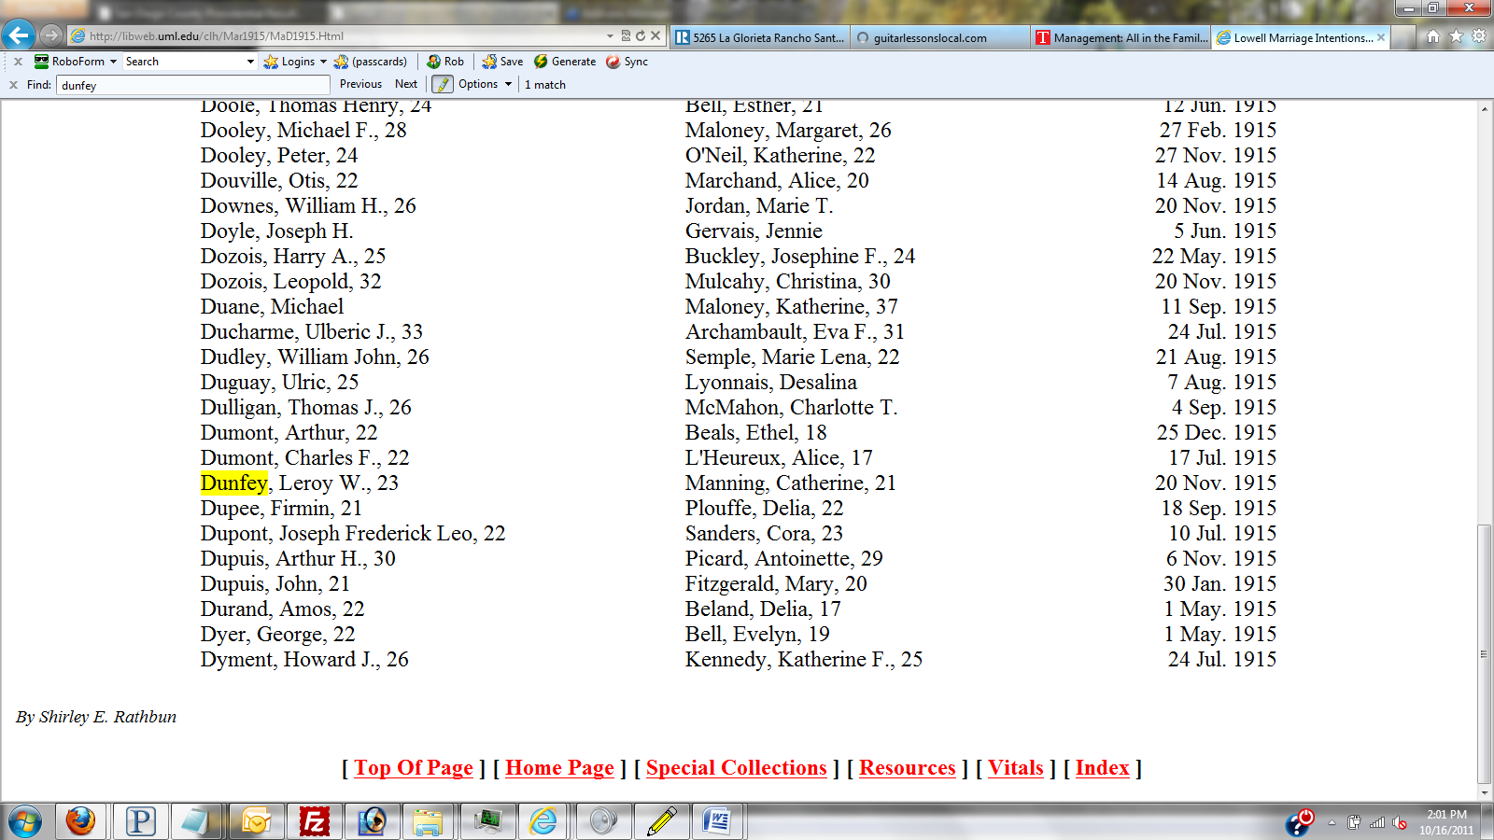Marriage date

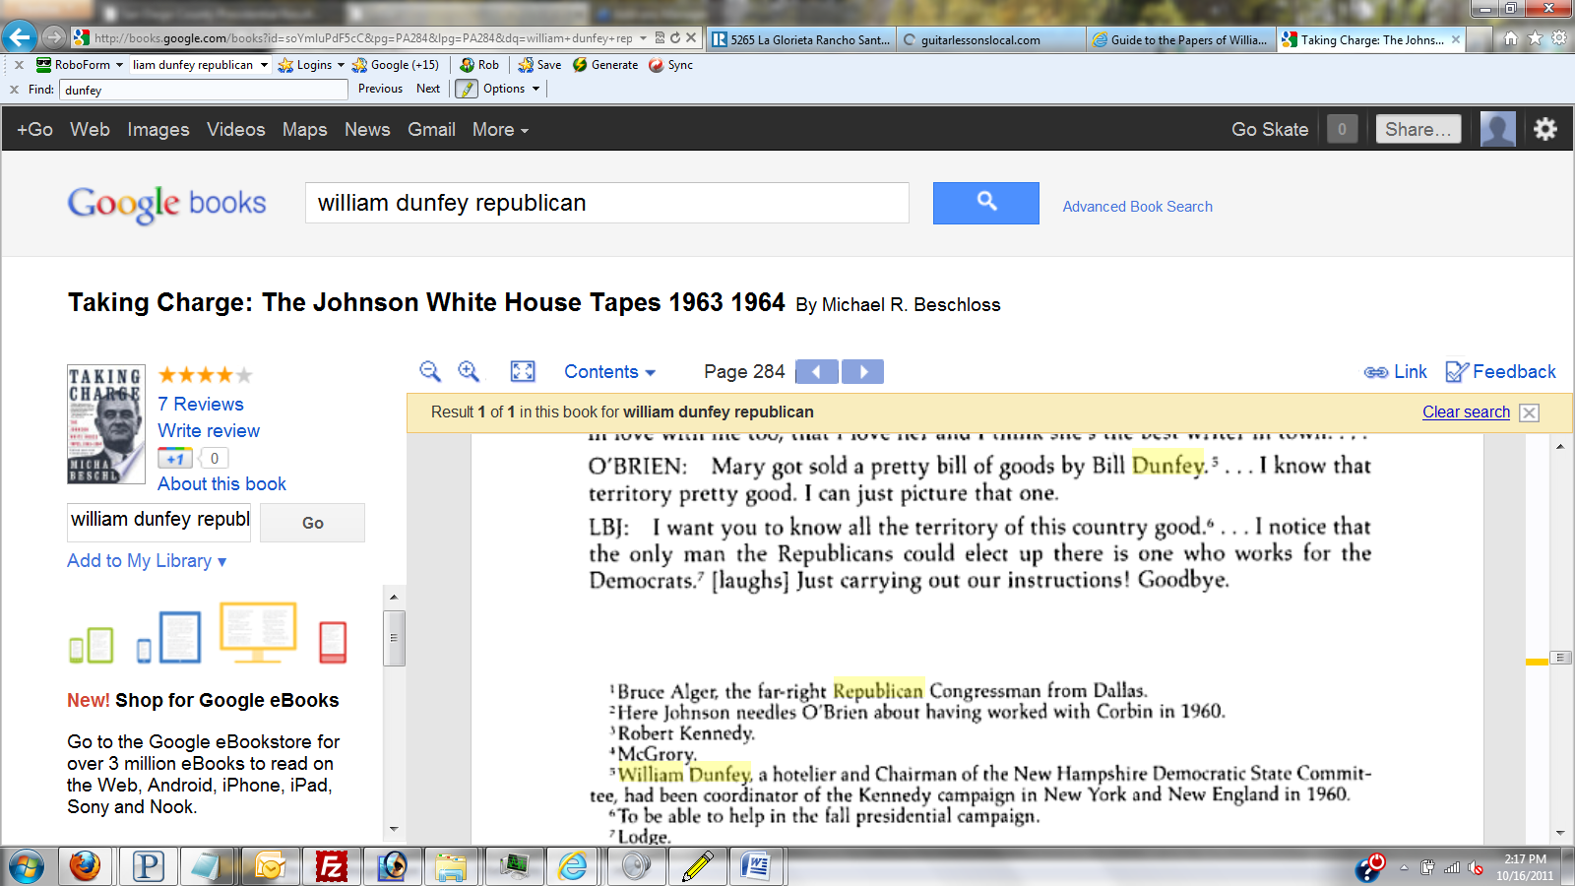
Lindon B. Johnson commenting on Bill Dunfey’s Activism in a White House Tape.

Guide to the Papers of William Dunfey, 1952 - 1991

Manuscript MS-1039
- Collection Overview
- Use & Access
- Introduction to the Collection
- Biography & History
- Series, Box & Folder List
- Full Finding Aid
- EAD XML (Staff only)
- Glossary

Search all Finding Aids

Contact Information
- Rauner Special Collections Library
- Dartmouth College
- 6065 Webster Hall
- Hanover, NH 03755-3519 USA
- Telephone: 603-646-2037 begin_of_the_skype_highlighting 603-646-2037 end_of_the_skype_highlighting
- Fax: 603-646-0447
- Rauner.Reference@dartmouth.edu

Biography & History

Biography
Born October 10, 1925 in Lowell Massachusetts, William Dunfey was the 6th of 12 children. He enlisted in 1943 and served overseas as a Marine in the Pacific during the second World War. Upon returning from the war, Dunfey attended the University of New Hampshire and received his Bachelor's and Master's degree. After the war, Bill and his brothers bought a clam shack at Hampton Beach, and founded the Dunfey Hotels chain (which was later absorbed by Omni Hotels). Years later the brothers formed the Dunfey Group, a venture capital firm. A prominent figure in NH politics, Dunfey gave considerable amounts of money to both Democrats and Republicans. He served on the campaigns of numerous Democrats, working for both Lyndon Johnson and John Kennedy. In addition, he was appointed to the UN by President Carter as an alternate representative for the 34th General Assembly. Dunfey supported numerous activists groups and social organizations, including the Center for Constructive Change, the Seacoast Anti-Pollution League, and the New England Circle. He was a trustee of both UNH and Dartmouth Medical School, and also created or helped support numerous publications in New Hampshire, including the monthly news magazine the Spectator, the international news service WorldPaper, and the New Hampshire Times weekly. He died February 9th, 1991, at the age of 65.

FROM JFK LIBRARY-------------------------------------------
The Personal Papers of William L. Dunfey, 1925-1991 (#63)
Biographical Note
William Leo Dunfey was born on October 10, 1925, in Lowell, MA. From 1943 to 1946, Dunfey served in the U.S. Marine Corps. Dunfey became involved with the Democratic Party in his twenties, when he joined the Young Democrats Club of New Hampshire. He received his B.A. from the University of New Hampshire in 1950. That same year, he founded Dunfey Association in Hampton, NH, which later became Dunfey Corporation in 1956. Dunfey supervised management training programs and was involved in real estate, insurance, and the hotel business, becoming a successful owner of inns in New England and, after his withdrawal from politics, throughout the U.S. In 1952, Dunfey was a participant in the Democratic Nation Convention, held in Chicago, Ill. He later acted as a regional representative for the Democratic National Committee to several Northeastern states, among them the New England states, New York, New Jersey and Delaware (1958-1960). During the 1960 presidential campaign, Dunfey was John F. Kennedy's campaign coordinator for Maine, New Hampshire and Vermont. Then for Lyndon B. Johnson's 1964 presidential campaign, Dunfey was campaign coordinator for New England and New York. From 1965 to 1967, Dunfey chaired the Democratic State Committee for New Hampshire. In 1968, Dunfey returned to the campaign trail as campaign coordinator in New England for Robert F. Kennedy. William Dunfey died in 1991
--------------------------------------------------------------

Principle was paramount in William L. Dunfey's politics
The Boston Globe (Boston, MA)

February 17, 1991 | John Milne, Globe Staff | Copyright

APPRECIATION
HAMPTON -- William L. Dunfey was a leader of New Hampshire's Democratic Party when John A. King and Hugh J. Gallen were elected governor, when Thomas J. McIntyre captured a US Senate seat and when J. Oliva Huot and Norman A. D'Amours went to Congress. He became known as a political guru.
After Dunfey retired from the political stage in the early 1980s, John A. Sununu, as the new governor, led the Republicans back to the domination to which they have now become accustomed.
Dunfey's ability to help elect Democrats in a conservative Republican state, …

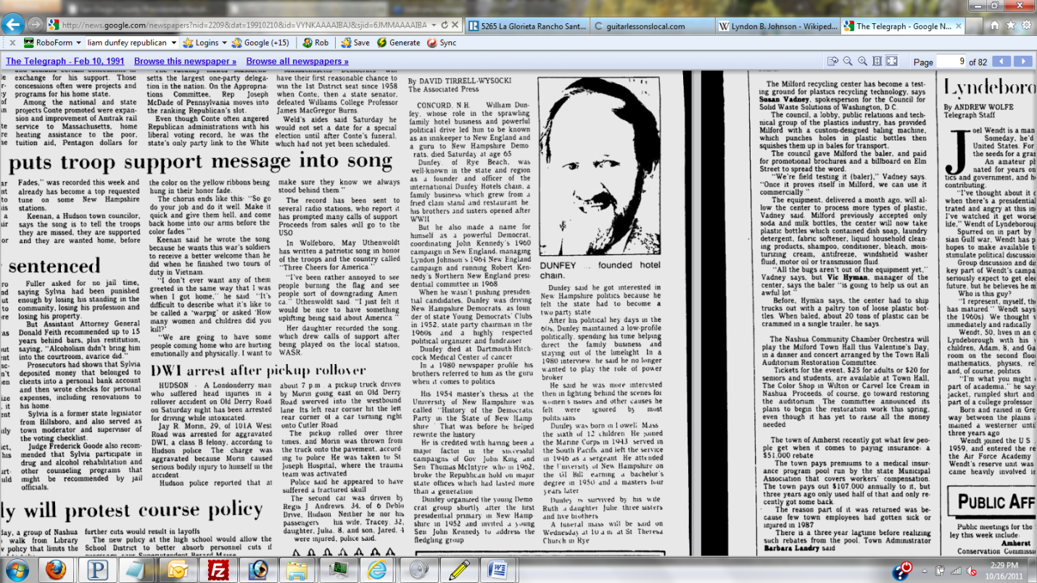

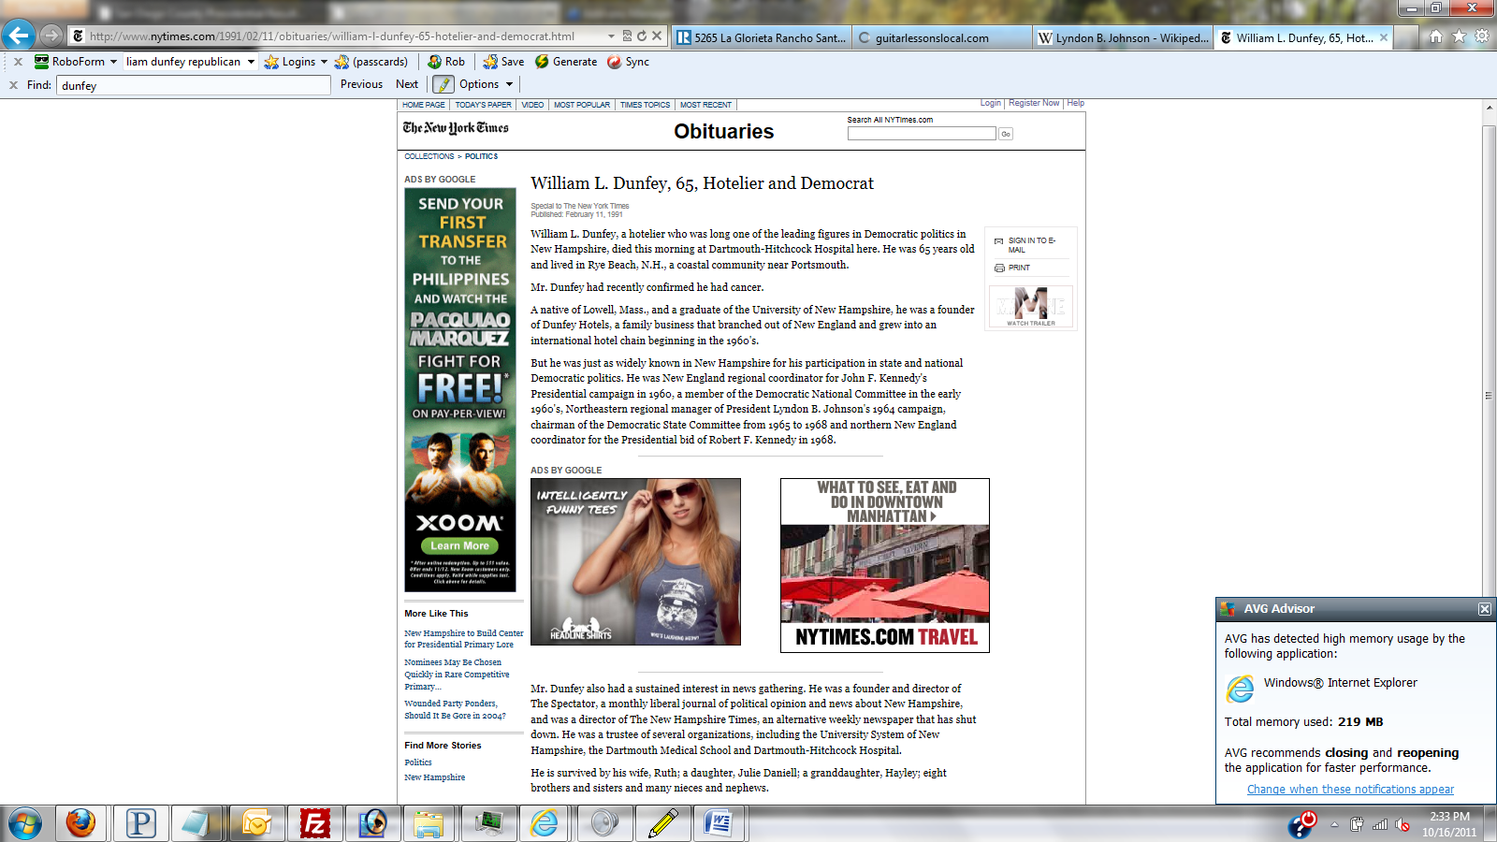

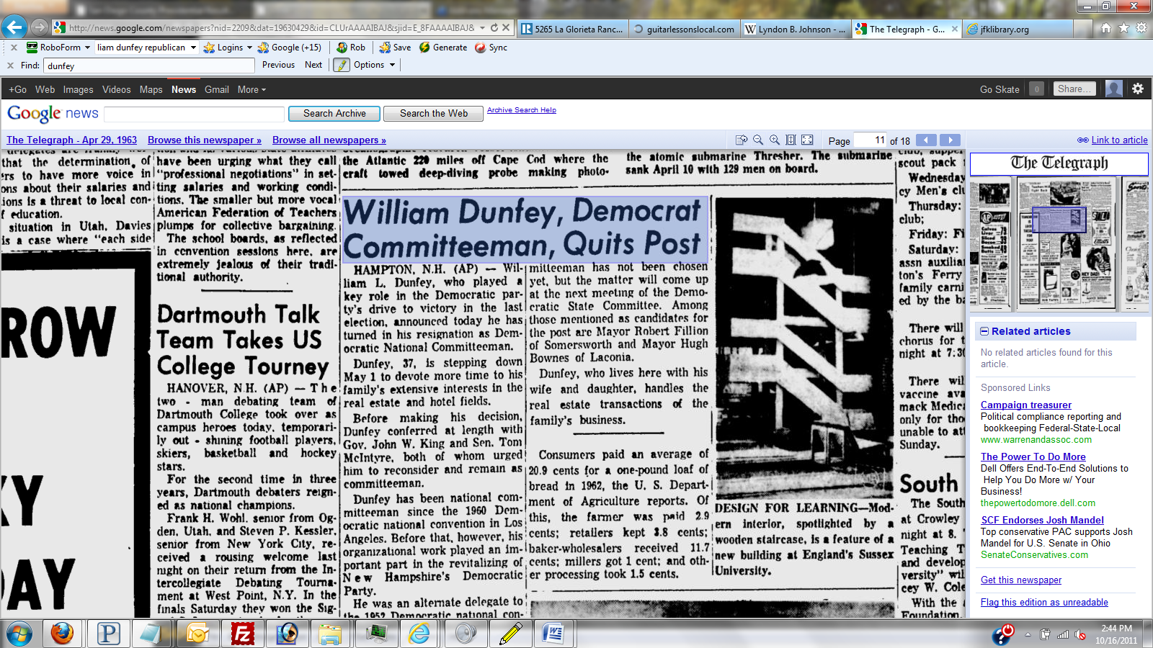
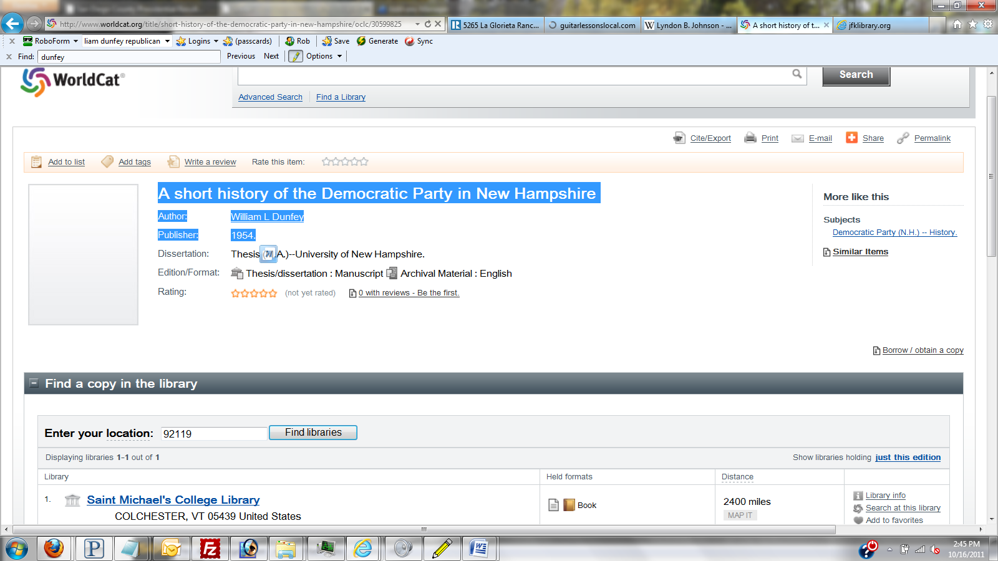

Omni Hotels Corp.

Address:
500 Lafayette Road
Hampton, New Hampshire 03842
U.S.A.

Telephone: (603) 926-8911
Fax: (603) 926-6613

Statistics:
Wholly Owned Subsidiary:
Incorporated: 1958 as Dunfey Hotels Corporation
Employees: 8,000
Sales: $500 million
SICs: 7011 Hotels & Motels

Company History:
Omni Hotels Corp. operates a group of unique, upscale, full-service hotels located mostly in urban centers. The company is a subsidiary of Hong Kong-based Wharf Holdings Limited. In 1994, Omni operated about 47 hotels with over 15,000 rooms in the United States, Mexico, and Asia. Backed by its well-heeled parent, Omni began expanding rapidly in the early 1990s.

Omni Hotels's history traces back to the five Dunfey brothers' clam stand. In 1945, the five Dunfey brothers started a clam stand in Hampton Beach, New Hamspshire. The success of their clam stand enabled the brothers to purchase and open other businesses. Most notable among the Dunfeys' purchases was Lamie's Tavern, a combination restaurant and motor inn located not far from their clam stand. The Dunfeys primarily wanted the restaurant, but the owner insisted that the adjoining 32-room hotel be part of the deal. The brothers adopted a theme of "Good old New England hospitality" for their hotel and touted the restaurant as a "cracker barrel lounge."

The success of the Lamie Motor Inn convinced the Dunfeys that they could make more money as innkeepers than they could running restaurants. They purchased their first real hotel (332 rooms) in 1958 and founded the Dunfey Hotels Corporation. During the late 1950s and early 1960s the brothers, under the guidance of company president Jack Dunfey, bought several other properties throughout New England. The Dunfeys became some of the first pioneers of hotel franchising in 1964 when they obtained several existing hotels and motor inns that bore the Sheraton name. With their Sheraton inns acquisition, the Dunfey Hotels Corporation became the largest hotel franchise holder in the world with a total of 14 inns.

By the mid 1960s, the Dunfeys had hotels and operating offices scattered throughout Massachusetts, Maine, and New Hampshire. The properties were successful partly as a result of the Dunfeys' marketing and management strategies. For example, they retained their original New England hospitality slogan and integrated the cracker barrel lounge into many of their hotels. They consolidated their acquisitions's management into the Dunfey Hotels Corporation's New England headquarters to maintain control over their growing operation. The Dunfeys also devised a strategy of targeting struggling hotels in need of renovation that they could buy inexpensively. In 1968, for instance, they bought the financially ailing Parker House in Boston, renovated the facility, and returned it to profitability.

Success with the Parker House served as an incentive for the Dunfeys. Although they wanted to continue expanding, they lacked capital. So, in 1971 they sold all 18 of their hotel and motor inn properties to Aetna Life Insurance Company. Aetna became the owner but retained the Dunfeys to operate them. The Dunfeys were successful at managing the hotel chain and earned the company a reputation for innovation. In 1968, for instance, they started a "Wayfarers Club" that gave perks like free travel insurance, coffee, and newspapers to their most frequent patrons. That successful program became a model for the frequent traveler programs that became commonplace by the 1980s. The Dunfeys also initiated the "Colleen Club," or secretaries club, which provided benefits to both the traveler and the person that made the reservations.

In 1976, Aer Lingus, an Irish airline company, purchased Dunfey Hotels from Aetna. Under Aer Lingus, Dunfey Hotels stepped up its efforts to penetrate the upscale hotel market through the company's Classic Hotel Division, which included only one property in 1976. The Classic Hotel Division was the foundation upon which the Omni Hotels would be built. In 1977, the company added a second holding to its Classic Hotel Division, the Ambassador East Hotel in Chicago. Still under the management of the Dunfey brothers, that property was renovated and its profitability improved. In 1978, Dunfey Hotels purchased the renowned Berkshire Place Hotel in New York. Following a major renovation in 1979 that jewel became the centerpiece of all Dunfey properties. The Berkshire Place would later undergo another complete renovation in the mid-1990s and was expected to reopen in the fall of 1995 as the top four star hotel in New York. Also in 1979, Dunfey Hotels bought the Shoreham Hotel in Washington, D.C.

By 1980, Dunfey Hotels Corporation owned or managed about 9,000 rooms in hotels mostly on the East Coast. Throughout the 1980s the corporation sought to expand its Classic Hotel Division. In 1981, it acquired New Orleans's Royal Orleans Hotel and the Biltmore Plaza Hotel in Providence, Rhode Island. Those purchases brought the number of properties in the Classic Hotel Division to five. Importantly, in 1983 Dunfey Hotels acquired Omni International Hotels, a company that operated three hotels in Atlanta, Norfolk, and Miami. Dunfey Hotels also added the once esteemed Netherland Plaza Hotel in Cincinnati, which it soon restored to its original art deco grandeur.

After the 1983 Omni acquisition Aer Lingus decided to adopt a new business strategy. It chose to develop a hotel chain called Omni Hotels. The new group of hotels would consist of more upscale properties and would be built from the existing Classic Hotel Division holdings. To that end, the company was reorganized into two separate operating divisions: Dunfey Hotels and Omni International Hotels. Omni consisted of nine hotels. Dunfey Hotels was a conglomeration of 14 hotels and motor inns that were operated under independent or franchise names, or under the Dunfey name.

During the 1980s, Aer Lingus gradually liquidated its Dunfey holdings jettisoning its last property in 1992. The Dunfeys sold all of their interests in the company that they had founded. They formed a new company, the Dunfey Brothers Capital Group, a venture capital company oriented toward socially responsible companies. Aer Lingus used cash from the sale of its Dunfey properties to fund the expansion and improvement of Omni. It opened the Baltimore Omni International Hotel in 1984 and the Omni Sagamore Resort in 1985. It also added two properties in Detroit, Michigan, and Charlottesville, Virginia.

To speed up expansion, Omni's management elected to begin franchising the Omni brand to selected hoteliers in 1986. Subsequently, in that same year, the Omni International Hotel in Orlando, Florida, and the Omni Charleston Place in South Carolina were opened. Omni Hotels' strategy during the early and mid-1980s was to buy, create, and manage unique, upscale hotels, mostly in downtown areas. Rather than creating a chain of identical inns, as did many of its industry peers, Omni focused on creating a group of independent, unique properties that would still add value to the Omni name. The effort worked; by the mid-1980s, Omni was recognized as a leading operator of upscale hotels.

Omni thrived during the 1980s, but so did many other hoteliers. The 1980s was an era of explosive growth for the hotel industry. As demand by travelers surged, the hotel industry embarked on an aggressive building spree. The expansion was possible largely because of favorable tax laws and an influx of investment capital into the real estate development sector. By the end of the decade, more than three million hotel rooms existed in the United States, most of which had been constructed since 1980.

The difference in Omni's expansion during the 1980s and that of many other upscale hotel chains was that Omni's growth was slower. Although it had built its chain to 36 by 1987, it had simultaneously divested other of its holdings through the Dunfey Hotels Division. Furthermore, Omni had been very selective about the properties that it added to its portfolio, buying hotels that it felt were undervalued and keeping its total debt low in relation to many of its highly leveraged competitors. Because of its comparatively cautious stratagem, Omni would be positioned to take advantage of the nasty hotel industry shakeout that would lambaste its rivals in the 1990s.

Ownership of Omni Hotels changed hands again in 1987. World International Holdings Limited and its associate Wharf Holdings Limited of Hong Kong bought the company from Aer Lingus for $135 million. World International was a massive diversified conglomerate, with annual revenues of over $5.6 billion, which represented ten percent of the entire Hong Kong stock market. World International was known as a very conservative, savvy organization with a reputation for buying undervalued companies that it could finance and turn into long-term performers. Omni's new parent company already owned a small chain of upscale hotels in Hong Kong and Singapore called Marco Polo International Hotels. It changed those properties to Omni Hotels. Also in 1987, Omni added its first hotel in Mexico, the Omni Cancun Hotel.

Omni continued to expand during the late 1980s, but escalating property prices slowed its progress. In addition, Omni dealt with two failed properties in the late 1980s. In 1988, a project involving the restoration of a historic mission in Riverside, California, failed when the developer went bankrupt. A year later another California property, which was franchised by Omni, failed as a result of bad dealings by the owner that were outside of Omni's control. Despite modest setbacks, Omni added nine new holdings to its portfolio between 1987 and 1991, boosting its total number of properties to 45.

By 1991, the hotel industry was in the depths of a downturn that had started in the late 1980s. Changed tax laws, a dearth of new investment capital, and an overbuilt market combined to force the hotel industry into a depression of historic proportions. As demand decreased, the average pretax profit gleaned from a U.S. hotel room dropped from a profit of over $1,500 per year in the late 1980s to a loss of $719 by 1991 As industry revenues plunged, the average market value of a hotel room plummeted from $23,600 in 1988 to a $18,400 by 1992, representing a devaluation of industry assets of more than 20 percent in just four years. The average hotel built after 1985 had lost $5,000 per room by 1991. Many hotel owners and operators were forced out of business and had to forfeit their properties to lenders, or to the federally backed Resolution Trust Corporation.

In 1991, Wharf Holdings Limited purchased World International's share of Omni Hotels. Wharf installed a new management team headed by Jerry Best. Best replaced William Sheehan, who had piloted the company since Aer Lingus sold it in 1988. Best recognized opportunities in the industry despite industry woes. Because of property devaluation, a number of premier hotels were being sold for a fraction of their original value. Omni had resisted the temptation to expand irresponsibly during the industry heyday, so it was now in a position to build a portfolio of superior properties by paying rock-bottom prices.

Backed by Wharf's massive base of capital, Best and his team launched an aggressive five-year growth plan. The strategy included three primary goals: 1) to increase the number of North American properties from 39 to 60 by 1997; 2) to scrap any properties that did not complement Omni's market position; and 3) to seek ownership or management contracts with four-star properties in the top ten or 12 U.S. markets. Omni added just one more hotel in 1991, the Omni Houston Hotel. In 1992, though, Omni contracted three new franchises, acquired full equity in two of its properties, purchased a hotel in Dallas, and entered into a management contract for a property in Austin, Texas.

Although Omni was able to take advantage of cut-rate property prices during 1992, the industry began to show signs of recovery. The average U.S. hotel room generated a meager profit of $159 in 1992, which served to buoy property prices in 1993. In 1993, Omni secured a flagship hotel in Chicago, the Chicago Hyatt Regency, which became the Omni Chicago Hotel. It also broadened its presence in Mexico with the addition of a franchise in Juatulco. Additional purchases early in 1994 boosted Omni's worldwide holdings (in operation or under development) to 45 hotels comprising 17,000 rooms. Thirty-six of the hotels were in the United States, two in Mexico, three in Hong Kong, and two in Singapore and Vietnam. Two more properties were scheduled to open in 1995, one in China and another in Indonesia, and several other negotiations were in progress.

By 1994, Omni generated approximately $500 million in annual revenues and employed a work force of more than 8,000. Its upscale and luxury hotels averaged 300 to 400 rooms and were generally oriented to corporate business travelers and business groups and associations. Going into the mid 1990s, Omni was focusing on continued U.S. expansion, particularly on the West Coast, through acquisition, franchising, and management contracts. It was also targeting selected regions in the Far East and Mexico.

--------------------------------------------------------------------------------

--------------------------------------------------------------------------------
Further Reading:

Albertini, Steve, Omni Hotels History, Hampton, New Hampshire: Omni Hotels, 1994.
Albertini, Steve, Omni Hotels Follows Strategic Growth Initiative, Hampton, N.H.: Omni Hotels, 1994.
McClain, Tim, "Bigger Presence in West still Sought by Omni," San Diego Daily Transcript, November 19, 1991, p. 1.
Miller, Leslie, "Once Dunfey-Owned Omni Hotels Seek Bargains as Other Chains Divest Properties," New Hampshire Review, August 7, 1992, p. 2.
Moskowitz, Daniel B., "Challenges on Trademarks Are Everywhere for Omni Hotels," Washington Post, September 21, 1992, p. E11.
Source: International Directory of Company Histories, Vol. 12. St. James Press, 1996.
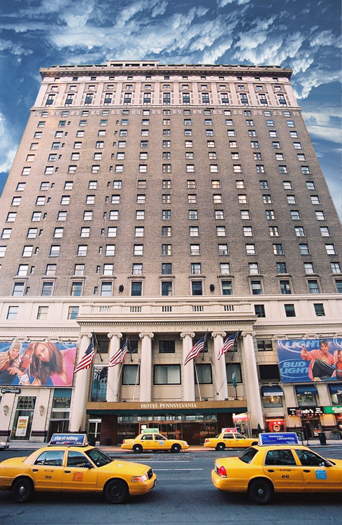 Hotel Pennsylvanie

